**Exercise 3: Stored Procedures**

**Scenario 1:** The bank needs to process monthly interest for all savings accounts.

* + **Question:** Write a stored procedure **ProcessMonthlyInterest** that calculates and updates the balance of all savings accounts by applying an interest rate of 1% to the current balance.

**Queries:**

INSERT INTO Accounts (AccountID, CustomerID, AccountType, Balance, LastModified) VALUES (3, 1, 'Savings', 10000, SYSDATE);INSERT INTO Accounts VALUES (2, 102, 2000, 'CURRENT');

INSERT INTO Accounts (AccountID, CustomerID, AccountType, Balance, LastModified) VALUES (4, 2, 'Checking', 8000, SYSDATE);

COMMIT;

**PL/SQL:**

CREATE OR REPLACE PROCEDURE ProcessMonthlyInterest IS

BEGIN

UPDATE Accounts

SET Balance = Balance + (Balance * 0.01),

LastModified = SYSDATE

WHERE AccountType = 'Savings';

COMMIT;

DBMS_OUTPUT.PUT_LINE('Monthly interest applied to all savings accounts.');

EXCEPTION

WHEN OTHERS THEN

DBMS_OUTPUT.PUT_LINE('Error occurred: ' || SQLERRM);

ROLLBACK;

END;

/

**Output:**

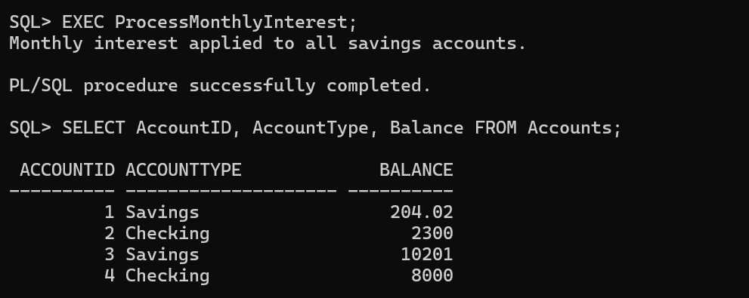

**Scenario 2:**

The bank wants to implement a bonus scheme for employees based on their performance.

* + **Question:** Write a stored procedure **UpdateEmployeeBonus** that updates the salary of employees in a given department by adding a bonus percentage passed as a parameter.

**PL/SQL :**

CREATE OR REPLACE PROCEDURE UpdateEmployeeBonus (

p_department IN Employees.Department%TYPE,

p_bonus_percent IN NUMBER

) IS

BEGIN

-- Update salary by applying bonus

UPDATE Employees

SET Salary = Salary + (Salary * p_bonus_percent / 100)

WHERE Department = p_department;

COMMIT;

DBMS_OUTPUT.PUT_LINE('Bonus of ' || p_bonus_percent || '% applied to department: ' || p_department);

EXCEPTION

WHEN OTHERS THEN

DBMS_OUTPUT.PUT_LINE('Error occurred: ' || SQLERRM);

ROLLBACK;

END;

/

BEGIN

UpdateEmployeeBonus('IT', 10);

END;

/

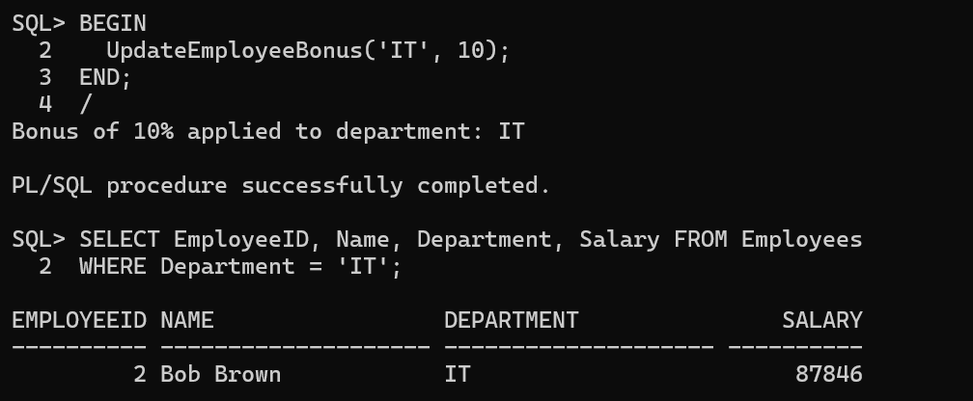**OutPut:**

**Scenario 3:**

Customers should be able to transfer funds between their accounts.

* + **Question:** Write a stored procedure **TransferFunds** that transfers a specified amount from one account to another, checking that the source account has sufficient balance before making the transfer.

**PL/SQL:**

CREATE OR REPLACE PROCEDURE TransferFunds (

p_from_account_id IN Accounts.AccountID%TYPE,

p_to_account_id IN Accounts.AccountID%TYPE,

p_amount IN NUMBER

) IS

v_from_balance Accounts.Balance%TYPE;

v_dummy NUMBER;

BEGIN

-- Lock and fetch balance of source account

SELECT Balance

INTO v_from_balance

FROM Accounts

WHERE AccountID = p_from_account_id

FOR UPDATE;

-- Ensure destination account exists and lock it

SELECT 1

INTO v_dummy

FROM Accounts

WHERE AccountID = p_to_account_id

FOR UPDATE;

-- Check for sufficient funds

IF v_from_balance < p_amount THEN

RAISE_APPLICATION_ERROR(-20001, 'Insufficient funds in source account (' || p_from_account_id || ')');

END IF;

-- Perform fund transfer

UPDATE Accounts

SET Balance = Balance - p_amount,

LastModified = SYSDATE

WHERE AccountID = p_from_account_id;

UPDATE Accounts

SET Balance = Balance + p_amount,

LastModified = SYSDATE

WHERE AccountID = p_to_account_id;

COMMIT;

DBMS_OUTPUT.PUT_LINE('₹' || p_amount || ' transferred from Account ' || p_from_account_id || ' to Account ' || p_to_account_id);

EXCEPTION

WHEN NO_DATA_FOUND THEN

DBMS_OUTPUT.PUT_LINE('One or both accounts do not exist.');

ROLLBACK;

WHEN OTHERS THEN

DBMS_OUTPUT.PUT_LINE('Error: ' || SQLERRM);

ROLLBACK;

END;

/

BEGIN

TransferFunds(3, 4, 500);

END;

/

**OutPut:**

